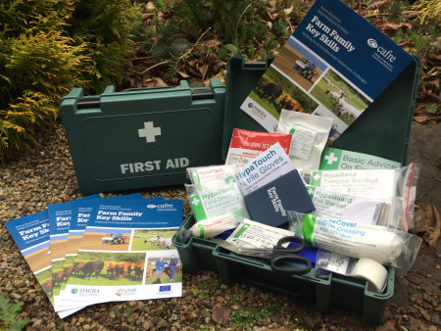
First Aid Training
Farm safety is critical, and all farm family members have a role to play to ensure any emergency situation on farm is dealt with confidently, promptly and safely.
Young Farmers’ Clubs of Ulster (YFCU), in partnership with the College of Agriculture Food and Rural Enterprise (CAFRE), is offering First Aid training opportunities throughout Northern Ireland for all members of the farm family.

Option 1: YFCU fully accredited Emergency First Aid at Work Qualification - £15 per member
- Full day Course
- Skills learned apply to all workplaces and the home
- Fully accredited qualification recognised throughout the UK that is valid for 3 years
- Includes First Aid manual and all course materials
- Counts towards YFCU President’s Award
- Excellent for your CV
- Available only to YFCU members aged 16+

Option 2: YFCU First Aid Training for Junior members - £3 per member
- 2 hour basic first aid course
- Skills learned apply to all workplaces and the home
- First Aid manual and certificate of attendance included
- Counts towards YFCU President’s Award
- Open to YFCU members aged under 16
For further information contact: Kevin Harper, Tel: 075 1799 9943 or email kevin.harper@yfcu.org
Club Leaders and Secretaries can also speak to Kevin about bespoke First Aid training club or county

Option 3: CAFRE Farm Family Key Skills First Aid Awareness Training - No cost
Three-hour course covering:
- Dealing with a medical emergency on a farm
- Basic first aid procedure for common farm-based injuries
- How to use the contents of a first aid kit
- Technologies to aid lone farm workers in an emergency
- Available to multiple farm families aged 16 and over and farm employees
- Each trainee will receive a CPR certificate, farm family first aid box and book
This training is provided as part of the Farm Family Key Skills [FFKS] scheme under the Farm Business Improvement Scheme (FBIS), part of the Rural Development Programme 2014-2020 which receives co-financing from the European Agricultural Fund for Rural Development (EAFRD).

For further information contact: Tel: 028 8225 6772 or email kevin.harper@yfcu.org

